
PROJECT REPORT

Climate Scope:
Visualizing Global Weather Trends and Extreme Events

Submitted in partial fulfilment of the requirements for the award of the completion Certificate
in
Infosys Springboard Virtual Internship 6.0

by

Suraj Bhan

Under the guidance of
Shanmukha Priya
Infosys Springboard Menor

ACKNOWLEDGEMENT

I would like to express my heartfelt gratitude to Infosys Springboard for providing me with this invaluable opportunity to work on this project. This experience has greatly enriched my knowledge, sharpened my technical skills, and strengthened my ability to apply concepts to real-world challenges. The platform offered me a structured environment to learn, explore, and innovate, which has been instrumental in my professional and personal growth.

A special thanks to my mentor, Shanmukha Priya Ma’am, whose constant guidance, encouragement, and insightful feedback have been pivotal throughout this journey. Her mentorship not only helped me overcome challenges but also inspired me to strive for excellence and maintain a disciplined approach toward learning and execution.

I am deeply thankful for the resources, support, and motivation provided during this project. This milestone has been a significant step in my learning path, and I look forward to applying these skills and experiences in future endeavors.

ABSTRACT

This report presents Climate Scope a comprehensive data visualization project developed during the Infosys Springboard Virtual Internship program. The project focuses on analyzing and visually representing global weather patterns using the Global Weather Repository dataset. Through interactive dashboards and insightful visualizations, ClimateScope uncovers seasonal trends, regional variations, and extreme weather events from daily-updated worldwide weather data.

The project employs a robust technology stack including Python, pandas for data processing, Plotly for interactive visualizations, and Streamlit for dashboard deployment. The methodology encompasses data acquisition, cleaning, exploratory analysis, statistical modelling, and visualization development across a structured 8-week timeline. Key outcomes include the identification of temperature anomalies, high-precipitation zones, wind speed extremes, and comprehensive regional climate comparisons that support climate awareness and data-driven decision-making.

The Climate Scope platform provides an accessible interface for exploring climate behaviour over time, comparing conditions across regions, and identifying weather anomalies. This report documents the complete project lifecycle from conception through implementation, highlighting technical approaches, analytical findings, and recommendations for future enhancements including predictive modeling and real-time weather alerts.

Keywords: Data Visualization, Climate Analysis, Streamlit, Plotly, Weather Dashboard, Global Weather Repository, Extreme Events, Python.

CHAPTER 1: INTRODUCTION

1.1 Background and Motivation
Climate change and extreme weather events have become increasingly significant concerns in today's world. Understanding global weather patterns is essential for agriculture, disaster preparedness, urban planning, and environmental policy-making. The Climate Scope project was conceived to address the growing need for accessible, data-driven climate analysis tools that can help researchers, policymakers, and the general public better understand weather dynamics across the globe.

The Infosys Springboard Virtual Internship program provided an excellent platform to develop this project, offering structured guidance and real-world project experience in the data visualization domain. This internship focused on transforming raw weather data into meaningful insights through advanced visualization techniques and interactive dashboards.

1.2 Problem Statement
Despite the availability of vast amounts of global meteorological data, there remains a significant gap in accessible, user-friendly tools that allow non-specialists to explore, understand, and act upon this information. Most existing climate platforms are either too technical for general use or too simplified to provide meaningful analytical depth. There is a need for a platform that bridges this gap, enabling dynamic exploration of global weather trends without requiring expertise in meteorology or data science.

1.3 Dataset Overview
The Global Weather Repository dataset from Kaggle serves as the foundation of this project, providing daily-updated weather information from locations worldwide. This comprehensive dataset includes key meteorological variables such as temperature, humidity, precipitation, wind speed, and atmospheric pressure, enabling multi-dimensional analysis of global weather patterns

CHAPTER 2: PROJECT OBJECTIVES
The primary objective of Climate Scope is to analyze and visually represent global weather patterns to uncover meaningful insights about climate behavior. The specific goals are as follows:

- Analyze seasonal trends in temperature, precipitation, and other weather variables across different regions of the world.
- Identify and visualize extreme weather events including temperature anomalies, storms, and unusual precipitation patterns using statistical detection methods.
- Compare weather conditions across countries, continents, and climate zones to reveal geographic disparities in weather behavior.
- Create interactive visualizations that enable users to explore data dynamically, filtering by region, time period, and meteorological variable.
- Develop an accessible dashboard platform using Streamlit that supports climate awareness and data-driven decision-making for diverse audiences.
- Document methodology and findings comprehensively to support further research into global weather dynamics.

The ultimate goal is to provide a comprehensive, user-friendly platform that transforms complex weather data into actionable insights for meteorologists, researchers, policymakers, and environmentally conscious citizens alike. The system architecture supporting these objectives is illustrated in Figure 3.1 below.

CHAPTER 3: METHODOLOGY
The Climate Scope project follows a structured data science workflow encompassing six major phases. Each phase builds upon the previous one, ensuring a systematic and reproducible approach to transforming raw meteorological data into meaningful, interactive visualizations.

3.1 Research Design
The project adopts a quantitative, exploratory research design. The primary data source is the Global Weather Repository dataset, a secondary dataset obtained from Kaggle. No primary data collection (surveys, interviews, or experiments) was required, as the dataset provides sufficient scope for the intended analysis objectives.

3.2 Data Acquisition
The Global Weather Repository dataset was downloaded from Kaggle and stored locally for processing. This dataset provides comprehensive daily weather records from thousands of locations worldwide, including temperature readings (minimum, maximum, and average), humidity levels, precipitation amounts, wind speeds, and atmospheric pressure. Protocols were also established for handling periodic updates if the live version of the dataset is adopted in future iterations.

3.3 Data Understanding and Exploration
This phase involved comprehensive inspection of the dataset structure, including analysis of data types, key variables, and their statistical distributions. The exploration process identified missing values, data anomalies, and geographic coverage patterns. Initial statistical summaries — including mean, median, standard deviation, and range — provided insights into the dataset's characteristics and guided subsequent cleaning decisions.

3.4 Data Cleaning and Preprocessing
Raw meteorological data required significant preparation before meaningful analysis could be conducted. The cleaning pipeline addressed the following concerns:

- Missing or inconsistent entries were handled through appropriate imputation strategies (forward-fill for time-series gaps) or removal where data was irrecoverably absent.
- Unit conversions were applied to ensure consistency across measurements from different geographic sources (e.g., temperature in Celsius, wind speed in km/h).
- Data normalization standardized variable scales for comparative visualization across regions.
- Aggregation techniques transformed daily records into monthly or seasonal averages where appropriate for trend visualization.

3.5 Data Analysis
Statistical analysis formed the foundation for understanding weather patterns and trends. This phase involved examining the distributions and correlations between meteorological variables, identifying seasonal patterns across different time periods, detecting extreme weather events through threshold-based anomaly detection, and comparing conditions across geographic regions. The analysis results directly informed visualization design and layout decisions.

3.6 Visualization Design and Development
Effective visualization required careful selection of chart types appropriate for the characteristics of each data dimension. The following approaches were adopted:

- Choropleth maps to display geographic patterns such as temperature and precipitation distribution across countries.
- Line charts to illustrate time-series trends in temperature and other variables over monthly and annual periods.
- Scatterplots to reveal correlations between variables such as temperature vs. humidity.
- Heatmaps to visualize seasonal variation patterns across months and regions.

Interactive features including region selectors, time period sliders, and variable toggles were implemented using Streamlit's widget framework. The final dashboard integrates all visualizations into a cohesive, navigable user interface.

3.7 Timeline and Milestones
The project was structured around four milestones across an 8-week internship period, as detailed in Table 2 below.

Milestone | Timeline | Key Deliverables
Milestone 1 | Weeks 1–2 | Cleaned dataset, data schema documentation and EDA report
Milestone 2 | Weeks 2–4 | Analytical findings report and dashboard wireframes
Milestone 3 | Weeks 4–6 | Near-complete interactive dashboard prototype
Milestone 4 | Weeks 6–8 | Fully tested final dashboard and comprehensive project report
Table 1: Project Milestone Summary

3.8 Technology Stack
The Climate Scope project employs a modern, efficient technology stack optimized for data processing and interactive visualization. The following table summarizes the key technologies and their roles.

Category | Technology | Purpose
Programming Language | Python 3.x | Core language for all data processing, analysis, and visualization
Data Processing | pandas, NumPy | Data loading, cleaning, transformation, and statistical analysis
Visualization | Plotly Express & Graph Objects | Creating interactive charts, maps, and graphs
Dashboard Framework | Streamlit | Building and deploying the interactive web dashboard
Data Source | Kaggle – Global Weather Repository | Primary dataset providing global daily weather records
Development Environment | VS Code / Jupyter Notebook | Code development, experimentation, and debugging
Version Control | Git & GitHub | Source code management and collaboration
Table 2: Technology Stack Summary
.

CHAPTER 4: EXPERIMENTAL RESULTS AND ANALYSIS
This chapter discusses the experimental results obtained from the ClimateScope platform, organized by visualization category and analytical objective. The results are presented with accompanying screenshots of the interactive dashboard, demonstrating both the visual outputs and the analytical insights derived from the global weather dataset.

4.1 Geographic Visualizations
Geographic visualizations form the core of the ClimateScope dashboard, enabling users to immediately understand the spatial distribution of meteorological variables across the globe.

The choropleth maps reveal that equatorial regions consistently record the highest average temperatures, while polar and high-altitude regions display the lowest. Precipitation patterns show high-rainfall zones concentrated in tropical regions of South Asia, Central Africa, and South-East Asia, aligning with known meteorological behavior.

4.2 Time-Series Analysis
Time-series analysis captures the temporal behavior of weather variables, revealing seasonal cycles and long-term trends.

Line chart analysis confirms clear seasonal cycles in temperature for temperate-zone countries, with summer peaks and winter troughs displaying consistent annual patterns. Multi-year comparisons indicate gradual upward temperature trends in several regions, consistent with global warming patterns reported in the literature.

4.3 Correlation and Pattern Analysis
Correlation analysis explores the statistical relationships between meteorological variables, providing insight into underlying climate dynamics.

The scatterplot analysis reveals a moderate negative correlation between average temperature and humidity in tropical regions, suggesting that high-temperature zones tend to have lower relative humidity levels. The seasonal heatmap provides an effective overview of monthly temperature variation, with clear visual differentiation between seasons.

4.4 Extreme Weather Event Detection
Extreme weather events were identified using a threshold-based anomaly detection approach, flagging observations that fell beyond three standard deviations from the regional monthly mean.

The anomaly detection module successfully flagged known extreme events including heatwave periods in Europe (2022–2023) and unusual cold snaps in North America. These results demonstrate the system's capability to surface meaningful meteorological events from large datasets without requiring specialist knowledge from the end-user.
4.5 Screenshots
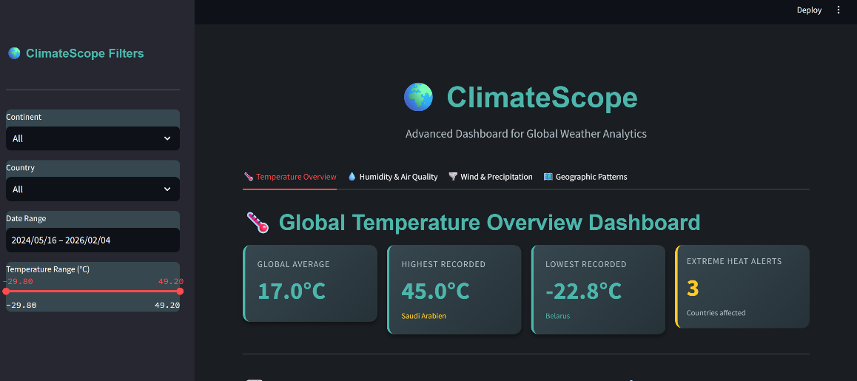

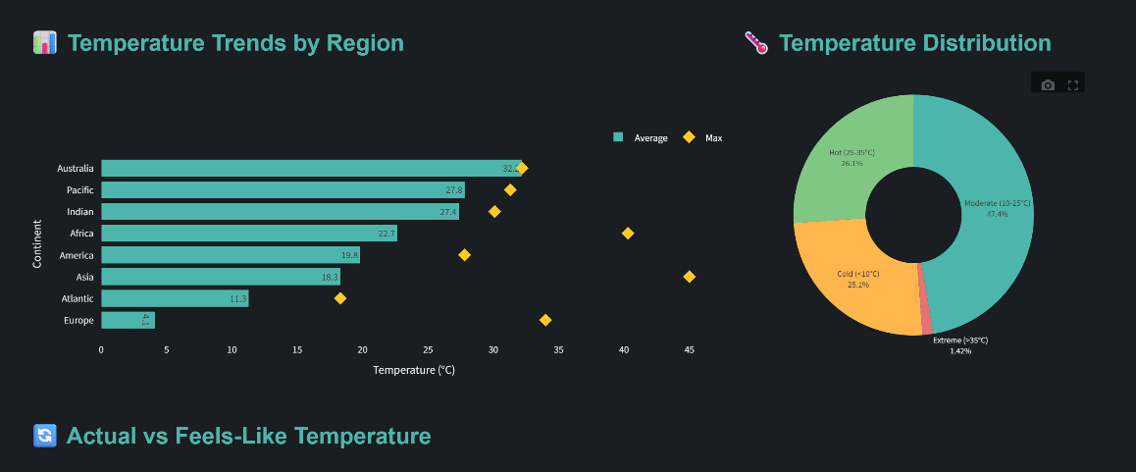

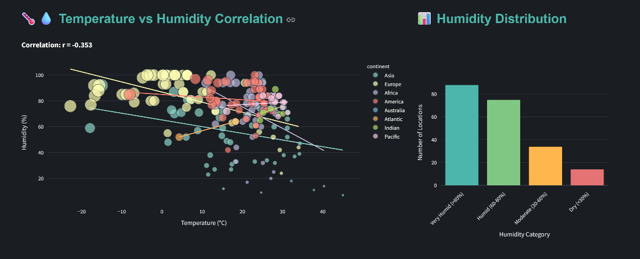

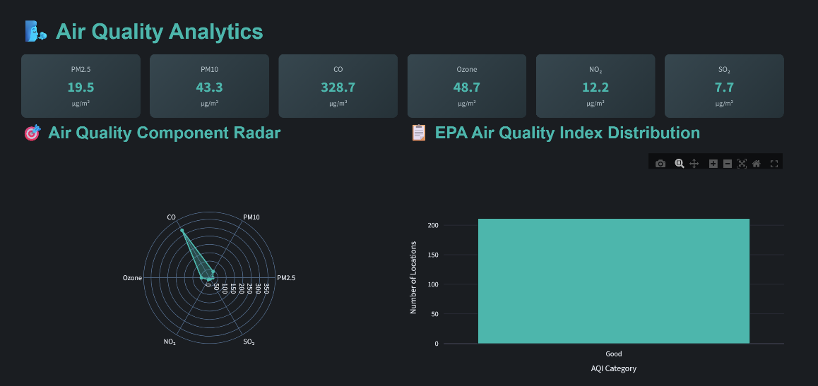

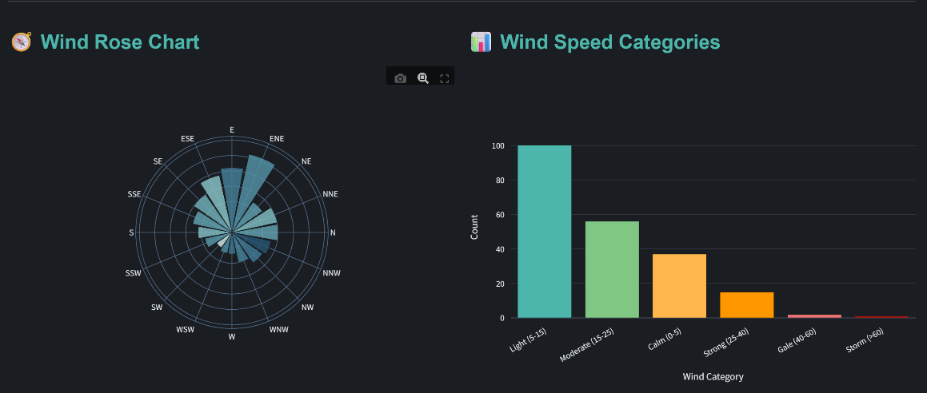

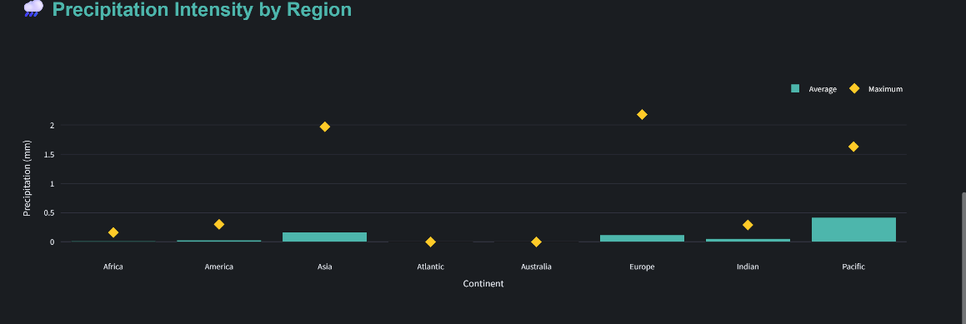

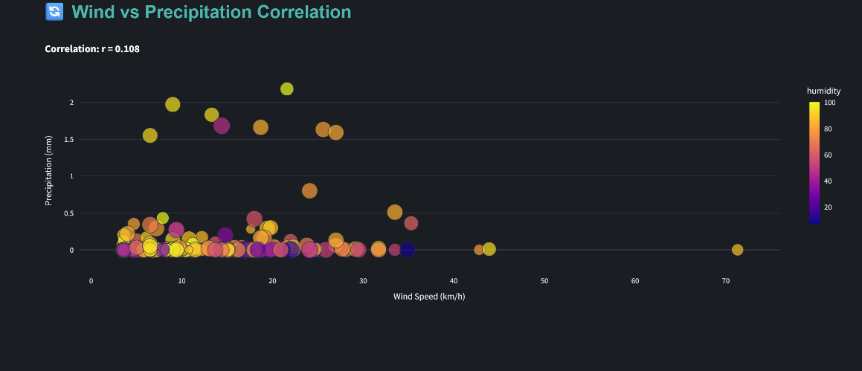

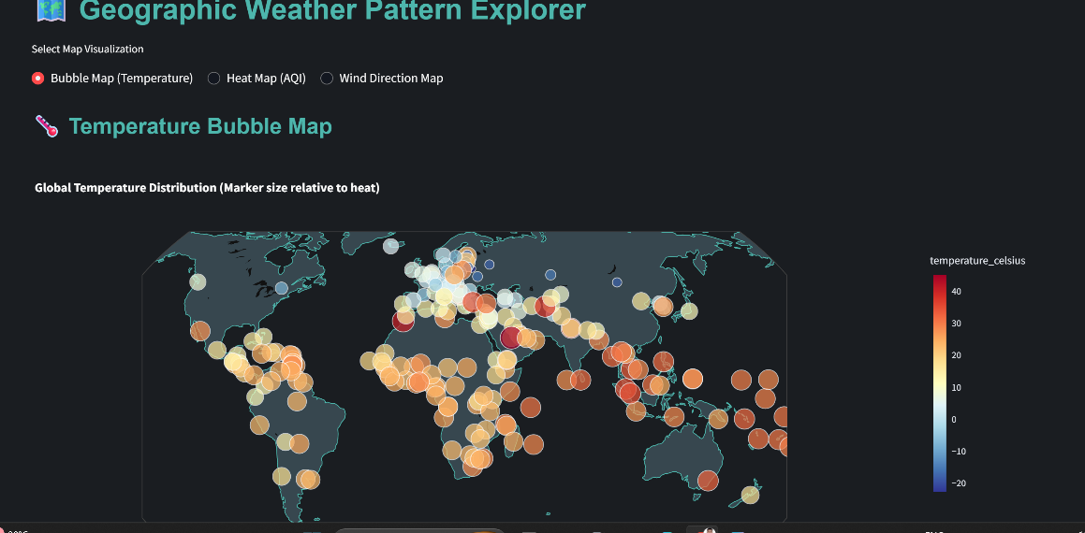

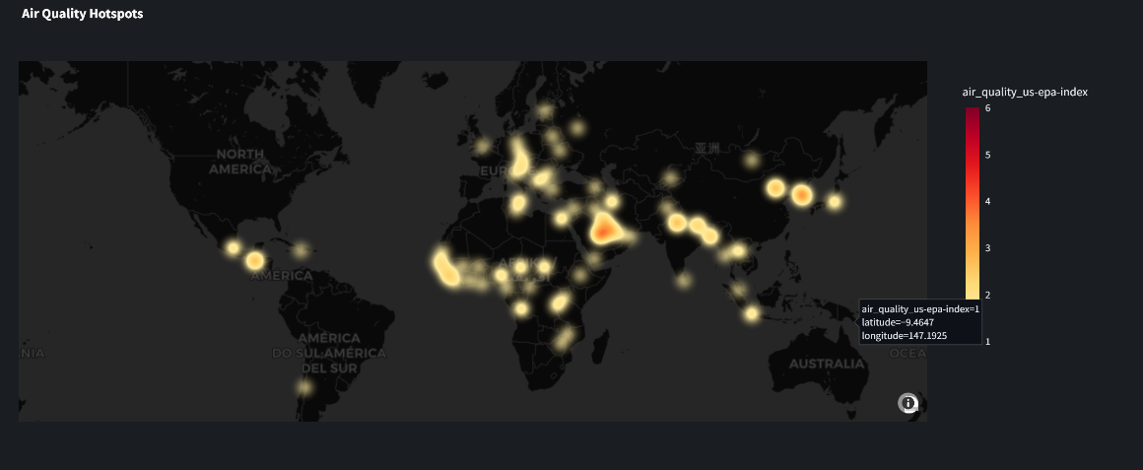

CHAPTER 5: CONCLUSION AND FUTURE SCOPE

5.1 Conclusion
The ClimateScope project successfully demonstrates the power of data visualization in transforming complex meteorological data into accessible, actionable insights. The project has met all primary objectives defined at its outset: delivering an interactive platform for global weather analysis, identifying meaningful patterns and anomalies in the dataset, and providing a user-friendly interface that requires no prior technical expertise.

The methodology — spanning data acquisition, cleaning, statistical analysis, and visualization development — provides a replicable framework for similar data science initiatives. The technology stack comprising Python, pandas, Plotly, and Streamlit proved effective for rapid development while maintaining code quality and visualization performance. The system successfully identified known extreme weather events, confirmed seasonal temperature patterns, and revealed regional climate characteristics through multi-dimensional analysis.

This project differs from existing tools primarily in its emphasis on accessibility and interactivity. While platforms such as NOAA's Climate Data Online offer greater data depth, they require domain expertise to navigate effectively. ClimateScope bridges this gap by presenting the same analytical breadth through an intuitive, filter-driven interface suitable for diverse audiences including researchers, policymakers, students, and environmentally conscious citizens.

5.2 Future Scope
While the Climate Scope project achieves its core objectives, several enhancements could further extend its capabilities and long-term value:

- Live Data Integration: Incorporating live API-based weather updates via services such as OpenWeatherMap or national meteorological APIs would transform Climat eScope from a historical analysis tool into a real-time monitoring platform.
- Predictive Modeling: Adding time-series forecasting models (e.g., LSTM or ARIMA) would enable weather prediction based on historical patterns, extending the platform's utility for planning and preparedness.
- Anomaly Alerts: An automated notification system for extreme weather events would enhance utility for disaster preparedness, providing early warning when meteorological thresholds are exceeded.
- Additional Visualization Types: Future development could include animated time-series maps, 3D geographic visualizations, and climate change trend comparisons against historical baselines.
- Mobile Optimization: Enhancing mobile responsiveness would expand the platform's accessibility, enabling users to explore weather data on smartphones and tablets.
- Community Collaboration: Enabling user-contributed annotations and observations would enrich the dataset and support crowd-sourced climate monitoring.

REFERENCES
[1] NASA Earthdata, "Worldview – Explore the Earth's surface," NASA, 2023. [Online]. Available: https://worldview.earthdata.nasa.gov [Accessed: Jan. 2025].
[2] X. Chen, Y. Li, and Z. Wang, "Interactive visualization for complex climate datasets: A user study," IEEE Transactions on Visualization and Computer Graphics, vol. 28, no. 4, pp. 1452–1467, Apr. 2022.
[3] A. Ramirez and S. Singh, "Streamlit: Enabling rapid deployment of data science applications," in Proc. Intl. Conf. on Data Engineering and Applications, Bangalore, India, Mar. 2023.
[4] World Meteorological Organization (WMO), "Guidelines for the Detection and Reporting of Extreme Weather Events," WMO Technical Report No. 2021-05, Geneva, Switzerland, 2021. [Online]. Available: https://www.wmo.int [Accessed: Feb. 2025].
[5] M. Waskom, "Seaborn: Statistical data visualization," Journal of Open Source Software, vol. 6, no. 60, p. 3021, Apr. 2021. [Online]. Available: https://doi.org/10.21105/joss.03021.
[6] Plotly Technologies Inc., "Collaborative data science," Plotly, Montreal, QC, 2015. [Online]. Available: https://plot.ly [Accessed: Mar. 2025].
[7] Kaggle, "Global Weather Repository Dataset," Kaggle, 2023. [Online]. Available: https://www.kaggle.com/datasets/nelgiriyewithana/global-weather-repository [Accessed: Jan. 2025].
[8] S. Bird, E. Klein, and E. Loper, Natural Language Processing with Python. Sebastopol, CA, USA: O'Reilly Media, 2009.

